


PRESS RELEASE Prague, 14th June 2018

A new square in Prague – BB Centrum builds public space for CZK 65 million

BB Centrum, a multifunctional complex in Prague 4, has transformed a former parking lot into a square. The new public space has an area of around 4500 m² and the sole investor of the construction, which exceeded CZK 65 million, was the development and investment company PASSERINVEST GROUP. The new square will primarily be used for gatherings, relaxation and refreshments or for holding cultural and sporting events and for enriching the public life in Prague. Along with the square, a pedestrian crosswalk and new bus bay were also built to make movement around the entire complex simpler and more pleasant.

Brumlovka Square was built over three months on the site of a public parking lot, which was here even before BB Centrum was created. Seven fifteen-year-old sycamore trees were newly planted on the square, plus there are 73 small tables here, places for sitting, flower pots with greenery and other park furniture. The square is comprised of a 2700 m² mosaic of stone imported from Portugal, a water feature, a jet fountain built into the walking area, and a special anchoring element, which has also been built in here for a Christmas tree.

By building Brumlovka Square, BB Centrum obtained extra space for the public and workers in BB Centrum. Thus they got a space where they can go during their midday pause for lunch, for an afternoon coffee or to sit with friends or colleagues in the evening, where seasonal and farmers’ markets, music and theatre performances and other additional cultural events will be held.

For example, there will be classic markets on Brumlovka Square on Friday, 22 June and from 6 to 9 August the summer mobile cinema Kinobus will be stopping here.

The investor of the project was PASSERINVEST GROUP and the design of the square comes from architect's office Aulík Fišer architekti.

You can find more information about the events in BB Centrum at facebook.com/BBCentrum.

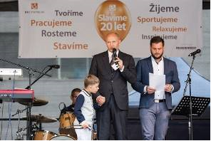

Radim Passer during a speech to open the Brumlovka Square in the BB Center

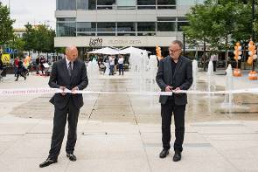

Radim Passer, PASSERINVEST GROUP, and Jan Aulík, Aulík Fišer architekti, jointly opened the new Brumlovka Square in BB Center

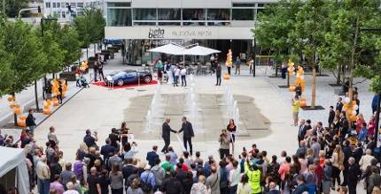

The opening ceremony of Brumlovka Square in the BB Center

For more information and photographs in print quality please contact:

Kristýna Samková, Head of PR and Marketing dept.
PASSERINVEST GROUP, a.s.
Tel.: (+420) 221 582 111
Mobil: (+420) 602 186 708
E-mail: Kristyna.Samkova@Passerinvest.cz
www.passerinvest.cz, www.bbcentrum.cz

Marcela Štefcová
Crest Communications a.s.
Mobile: (+420) 731 613 669
E-mail: marcela.stefcova@crestcom.cz
www.crestcom.cz

ABOUT THE DEVELOPER

PASSERINVEST GROUP, a. s., is a purely Czech development company, whose name is primarily connected with the construction of the multifunctional BB Centrum complex in Prague 4 – Michle. The company, founded in 1991 by Radim Passer, built a very good name on both a domestic and international level with this, the most successful and extensive Czech project of its kind. This is not only due to the quality of the implemented projects and the high level of provided services, but also to a sense of fair play, an accommodating relationship with the tenants/users of the buildings and the responsibility towards society and the environment. PASSERINVEST GROUP also has other interesting development projects in its portfolio.

